JB’s Holiday Activities  Yr 5 and 6 Athletics  Name …………………………………….  Class………………………………………  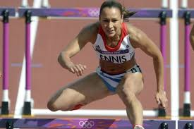 | How much can you remember about Athletics?  Q1) Name three heptathlon events?  ……………………………………………………………………………………………………  Q2) Name the Olympic throwing events?  ……………………………………………………………………………………………………  Q3) What is your favourite area of Athletics?  ……………………………………………………………………………………………………  Q4) Which area do you feel you could improve on the most with practice?  …………………………………………………………………………………………………  Q5) What is meant by endurance?  ……………………………………………………………………………………………………  Q6) What is meant by acceleration?  …………………………………………………………………………………………………….
Can you try the following?  - Can you record your fastest time for a 30metre sprint? Time………………….  - Can you record your longest standing long jump in steps? Distance……………..  - Can you record your longest over arm throw in steps? Distance………………….  - Can you record your longest combination jump (3 jump sequence) in steps? Distance……………………..  - Can you run at the same speed without stopping for 8 minutes?  _____________________________________________________  My …………………………………………… helped me try these challenges in the holiday.  Adult Signature …………………………………………………………………….. | Can you name fill in the blanks to find the Athletes’ names?  - U__A__N B__L__  - __ __ FA__A__  - JESS E__ __ __S  - __ __ __ __ RUTHERFORD  - DENISE L__W__S

