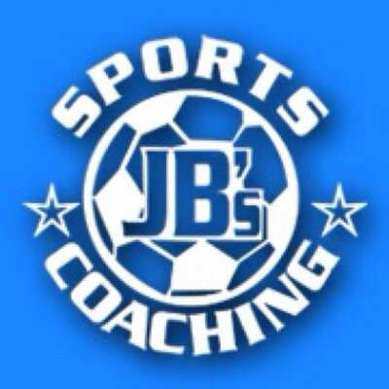  JB’s Holiday Activities  KS 1 Bat and ball  Name …………………………………….  Class………………………………………  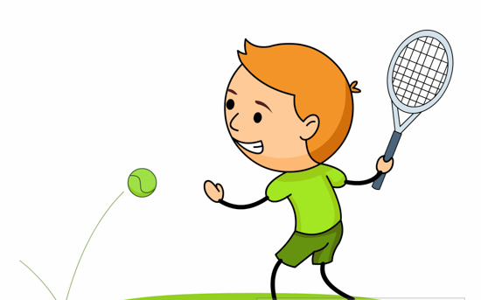 | How much can you remember about bat and ball?  Q1) What position should your body be in when hitting a ball?  - Side ways on  - Facing ball  - Backwards  Q2) In cricket, which side of the bat do you hit the ball with, flat or curved?  ………………………………………………………………………  Q3) In tennis you swing the racket from low to?  ………………………………………………………………………  Q4) The handshake grip was one of the grips we used in tennis, can you name the other?  ………………………………………………………………………
Can you try the following?  - Can you balance a ball on a tennis racket whilst moving?  - Can you bounce the ball of the racket strings 5 times?  - Can you hit a ball that’s been bowled towards you?  - Can you hit a ball to a partner for them to catch?  - Can you push the ball along the floor to a partner/target using a bat or racket?  _________________________________________________________  My …………………………………………… helped me try these challenges in the holiday.  Adult Signature …………………………………………………………………….. | Can you complete the racket dot to dot?  