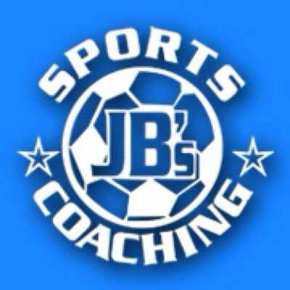  JB’s Holiday Activities  KS 1 Dance  Name …………………………………….  Class………………………………………  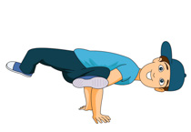 | How much can you remember about Dance?  Q1) Can you name a style of dancing?  ………………………………………………………………………  Q2) When dancing to music, you are listening for the what?  ………………………………………………………………………  Q3) How would you need to move if you were dancing to a fast song or piece of music?  ………………………………………………………………………  Q4) Name three different body parts that you can use when dancing?  ………………………………………………………………………
Can you try the following?  - Can you copy a dance that you have seen?  - Can you make your own dance to a song of your choice?  - Can you clap in time to the beat of a song of your choice?  - Can you copy a partners movements?  - Can you perform an action in slow motion?  _________________________________________________________  My …………………………………………… helped me try these challenges in the holiday.  Adult Signature …………………………………………………………………….. | Can you watch and then copy 5 of your favourite pop song dance routines?  What are they?

