JB’s Holiday Activities  KS 1 Gymnastics  Name …………………………………….  Class………………………………………  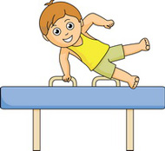 | How much can you remember about Gymnastics?  Q1) Can you name a pathway that you can travel in?  ………………………………………………………………………  Q2) Can you name three different ways in which you could travel?  ………………………………………………………………………  Q3) What is a balance?  ………………………………………………………………………  Q4) Name three different body parts on which you could perform a spin?  ………………………………………………………………………
Can you try the following?  - Can you travel in three different pathways?  - Can you travel on as many different body parts as possible?  - Can you demonstrate three different balances and hold each one for 5 seconds?  - Can you jump and land using the correct technique?  - Can you link two movements together?  _________________________________________________________  My …………………………………………… helped me try these challenges in the holiday.  Adult Signature …………………………………………………………………….. | Can you colour in the gymnast?  