JB’s Holiday Activities  KS 1 Throwing and Catching  Name …………………………………….  Class………………………………………  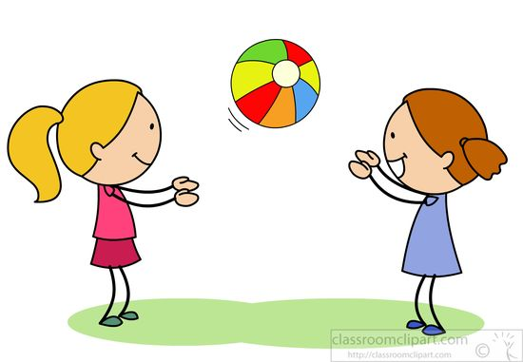 | How much can you remember about throwing and catching?  Q1) What shape should your hands be in to catch a ball?  ………………………………………………………………………  Q2) What should you always be looking at when catching?  ………………………………………………………………………  Q3) Which body part do you use to help you aim when throwing?  ………………………………………………………………………  Q4) Underarm is one throwing technique we practised, what is the other?  ………………………………………………………………………
Can you try the following?  - Can you throw and catch a ball 10 times on your own?  - Can you throw and catch a ball 10 times with a partner?  - Can you throw a ball underarm into a target from 5 steps away?  - Can you throw a ball underarm into the same target from 10 steps away?  - How far can you throw a ball using the overarm technique? Count your distance in steps.  ………….. steps  _________________________________________________________  My …………………………………………… helped me try these challenges in the holiday.  Adult Signature …………………………………………………………………….. | Can you colour in this boy throwing a ball?  